Parent Community Proposal

Diana Stein

ADMIN/541

September 4, 2017

Dr. David Berry

Depending on your school and district culture and its' previous relationship to the community, this can be a tough or fairly easy assignment and all school districts vary. In the ideal district there is already a foundation out there for the local school districts that families can contribute to for specific reasons and that foundation then grants the money to the district. I typically find this in high income areas, but often those districts may have adjacent districts that may not have the same funding and the district with the foundation for the schools may get significant inter district transfers from neighboring districts. The nice thing is that those families can contribute to the foundation, but they would not be a part of any local bond on home owners to fund the schools and at times that can be a political issue with the issuing of bonds. In those districts, there are established relations and points of contact to go to first to keep the relationships. In other districts that do not have that independent foundation there are often long established ties to the community, but things always change over time and relationships take time and effort on both sides. Your proposal was thoughtful, well thought out, above and beyond the scope of this assignment and would really help any parent who chose to participate and for those that did, it would build the relationship and create a group of involved parents. After reading your proposal I thought this would really be a training that you could actually "can" and start to offer to other districts and agencies and on the side be a trainer of this information. You have a clear outline and sequence of the information to present with up to date research to support you. It actually is very helpful to get a short statement of one's work or idea and your introductory sentence of "Community leadership where a shared commitment to the vision among all members of the school community is visible includes voice and choice of all involved." hits that mark and voice and choice will be remembered by those you train as the theme. A wonderful proposal that will offer significant training to your parents that can literally change the way they interact and support their children. Well done.

Dr. Berry 9/9

**Introduction**

Community leadership where a shared commitment to the vision among all members of the school community is visible includes voice and choice of all involved.   
A healthy school culture of collaboration includes working with diverse students and families, providing ways for families to get actively involved, rather than merely engaged to raise school wide learning results. The purpose of this paper is to propose tools via a three-part workshop series titled *Parent Empowerment Academy* that Parent Partners may take part in workshops and/or online modules as resources to raise the impact of student learning and character development at school and at home. Included in this proposal you will find:

**(A)** A description of the proposed Parent and Community Involvement program and what the research states on the topic.

**(B)** An explanation of the impact of a Parent and Community Involvement program on the school.

**(C)** Identification of the skills and content knowledge needed by the principal, teachers and teacher leaders to implement the program.

**(D)** A suggestion of a professional development plan for implementing the proposal.

**Parent Community Proposal**

The power that proactive parent partner relationships foster in a healthy school community cannot be understated. Everyday family interactions with school staff reinforce the connectedness that have the potential to move student learning results from average to exemplary. Parents who create authentic learning experiences for their children as home schooling partners are positioned as activators, rather than dispensers of information. The *Parent Empowerment Academy* is a proposed three-part parent education program:

* **Part I**: *Visible Learning* *Here and Now*
* **Part II:** *Excellence, Engagement, & Ethics*
* **Part III:** *Quantum Leaps in Learning*

**(A)** **Description of the proposed Parent and Community Involvement program and what the research states on the topic:**

**Part I**  
*Visible Learning* *Here and Now* **–** *The 8 Keys of Excellence* are our principles to live by, as they lay the framework for a supportive, trusting environment where each person is valued and respected (DePorter, 2000). The Keys focused on during Part I of our workshop series are:

* **Failure Leads to Success:** Praising progress, not perfection (Dweck, Khan)
* **This is IT:** Managing anxiety, taking risks and developing grit (Duckworth)
* **Commitment:** Developing self-confidence and perseverance (Gardner, Hattie)

The work of Howard Gardner, John Hattie, Angela Lee Duckworth, and Sal Khan will be resourced as key points for discussion. According to Duckworth, “… talent doesn’t make you gritty. Our data show very clearly that there are many talented individuals *who simply do not follow through* on their commitments. In fact, in our data, grit is usually unrelated or even inversely related to measures of talent” (Duckworth, 2013).

**Part II**  
*Excellence, Engagement, & Ethics* **–** Everything speaks. As Parent Partners you understand the importance of understanding our kids from a motivational perspective. The power of well-chosen words, and the power of actions *without words* are necessary tools to have in your toolbox. Challenges ofhome schooling includegetting on the same page with your kids.The next three Keys of Excellence that we will focus on are:

* **Speak with Good Purpose:** Limited lecture and multiple means of communication (e.g., Google docs, project-based learning, creative choice, etc.)
* **Integrity:** Student-centered, rigorous,and focused on mastery
* **Flexibility:** Student choice, movement, and presentations

This breakthrough approach including *How to Talk So that Kids Can Learn* demonstrates how parents and teachers can join forces to inspire kids to be self-directed, self-disciplined, and responsive to the wonders of learning (Faber & Mazlish, 1995). This informative workshop will provide you with down-to-earth dialogs using “non-negotiables” that will help you to get the most out of each homeschooling day together.

*(\*Please see Appendix B, “Non-Negotiables”)*

**Part III**

*Quantum Leaps in Learning* – Boost comprehension and retention, increase engagement and activate engagement, and tap into the genius in every student as you discover ways to create more interesting ways to deliver content and facilitate the learning process with easy-to-follow guidelines (DePorter, Reardon, & Singer-Nourie, 2010).

The final two Keys of Excellence that we will focus on are:

* **Balance:** Student-centered lessons with the instruction centered on our students. Students must demonstrate that they are our focus and that our focus is centered on their success (Cochrane Collegiate Academy, 2011).
* **Ownership:** Students take ownership of their learning by asking higher-ordered thinking questions, presenting knowledge using speaking and listening skills to demonstrate mastery using Thinking Routines (Harvard University, 2014).   
  *(\*Please see Appendix C, “Project Zero”)*

**(B)** **The impact of a Parent and Community Involvement program on the school includes avocation of:**

* Students taking agency over their own learning (Khan, 2015)
* Parents activating students to fill in gaps before moving forward (Khan, 2015)
* Personalization of learning for all students (Khan, 2015)
* Student processing of the lower level skills (basics) before moving on to the more advanced ones (Khan, 2015)
* Variation of when and how long a student needs to work on a concept before they move onto the next concept (Khan, 2015)
* Building grit and perseverance to reinforce the right mindset muscles (Khan, 2015)
* Providing the tools to provide explanation at students’ own time and place with on demand videos, practice, and feedback (Khan, 2015)
* Added simulations and Socratic dialog to create experiential learning (Khan, 2015)
* Observation of fears and acknowledgement to move them into opportunities (Khan, 2015)

**(C)** **Identification of the skills and content knowledge needed by the principal, teachers and teacher leaders to implement the program:**

* Parent partners, as well as credentialed teachers, will have online access to the training modules presented at the three-part *Parent Empowerment Academy* workshops. A resources page will be linked to each part of the series as it relates to each particular age and stage of pedagogy. Significant works will be shared from Gardner, Hattie, Khan, Dweck, and Duckworth as relevant to the topics outlined.

**(D)** **A suggestion of a professional development plan for implementing the proposal:**

The *Parent Empowerment Academy* is a proposed three-part parent education program that includes relevant, workshops plus on-demand interactive learning consisting of three FREE 90-minute workshops. The aim of this engaging series is to support Parent Partners as they build resiliency, independence, respect, and cooperation into their students and their daily home schooling programming. Our ultimate goal is to help our students to become thinkers, communicators, and achievers as they fostering harmony and successful family and peer relationships as they mature. This positive parenting program including three parts detailed in the body of this proposal:

* **Part I**: *Visible Learning* *Here and Now*Fall, 2017   
  *(\*Time to be coordinated with Principal Lasto and school calendar of events.)*
* **Part II:** *Excellence, Engagement, & Ethics*Winter, 2018   
  *(\*Time to be coordinated with Principal Lasto and school calendar of events.)*
* **Part III:** *Visible Learning in Quantum Leaps*Spring, 2018   
  *(\*Time to be coordinated with Principal Lasto and school calendar of events.)*

**Conclusion**

The *Parent Empowerment Academy* is designed to guide parents as they build upon skills and strategies for engaging their children during instructional time at home, and to provide behavior management systems in ways that support high expectations for *all* learners.  “It is essential to the management of the school that those who are charged with responsibility for directing its affairs understand the role of public attitudes in a democracy and their effect on the education of children (Moore et al, 2016).”

Strategies for creating a positive, safe, and supportive learning environment for all student groups by promoting equity and respect among all members of the school community will be modeled and made available to all Parent Partners/community members during workshops, and afterwards via on-demand interactive modules (online through Schoology) providing equitable access to the school, the curriculum, and available programmatic supports to all groups of students and their parents or guardians.

As Parent Partners become more actively involved with the school curriculum, the school staff, and how to facilitate their children as they meet the outlined state standards they will co-create positive working relationships that, over time, will become our wider community of learners. The end result of the *Parent Empowerment Academy* is the establishment of positive public relations with a proactive community that is based on trust and commitment leading to improved school wide learning results for all.

References

Cochrane Collegiate Academy. (2011, November 30). *How to engage underperforming students.* Retrieved from https://www.edutopia.org/: https://www.edutopia.org/stw-school-turnaround-student-engagement-video

DePorter, B. (2000). *The 8 Keys of Excellence*. Thousand Oaks, CA: Corwin Press.

Dweck, C. (2014). *The power of believing that you can improve.*Retrieved from https://www.ted.com/talks/carol\_dweck\_the\_power\_of\_believing\_that\_you\_can\_improve

Faber, A., & Mazlish, E. (1995). *How to talk so kids can learn*. New York, New York: Fireside.

Harvard University. (2014). *PZ thinking routines.*Retrieved from https://www.youtube.com/watch?v=oKV\_S5NpDdc

 Harvard University. (2014). *What is PZ?*Retrieved from https://www.youtube.com/watch?v=swRzk2qFKeU

Hattie, J. (2015). *John Hattie learning intentions & success criteria.*Retrieved from https://www.youtube.com/watch?v=dvzeou\_u2hM

Khan, S. (2015). *Let’s teach for mastery – not test scores.*Retrieved from https://www.ted.com/talks/sal\_khan\_let\_s\_teach\_for\_mastery\_not\_test\_scores

Moore, E. H., Bagin, D. H., & Gallagher, D. R. (2016). *The school and community relations* (11th ed.). Boston, MA: Pearson.

Visible Learning. (2017). *Visible Learning: What works best for learning.*Retrieved from http://john hattie visible learning pdf

**Appendix A** (Part I)

[The 8 Keys of Excellence](javascript:;)

The Classical Academies continue to use the "8 Keys of Excellence" to provide a framework for students to achieve success in school and their personal lives. We are excited about this school wide program and know that our students will benefit from it. The 8 Keys of Excellence character education program guides young people toward a positive future full of confidence, motivation, creativity, team work, leadership and valuable life principles.  For more information visit [www.8keys.org](http://www.8keys.org/" \t "_blank)

Parents can support their students as they go through the 8 Keys of Excellence at school by signing up for our Parent Empowerment Academy program. For more information visit: <http://www.8keys.org>

**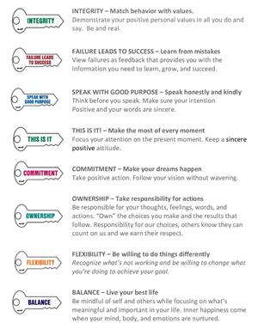**

(DePorter, 2000)

**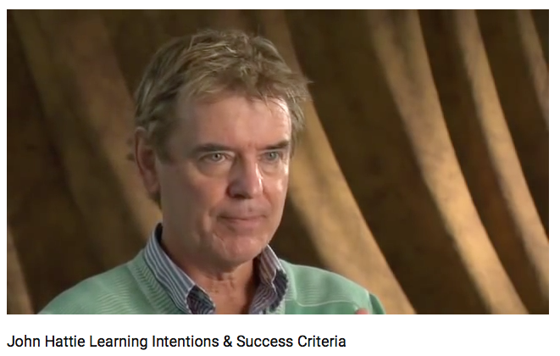**

**Reference**

Hattie, J. (2015). John Hattie Learning Intentions & Success Criteria. Retrieved from https://www.youtube.com/watch?v=dvzeou\_u2hM

**Appendix B** (Part II)

[Non-Negotiables](javascript:;)

The non-negotiables are the rules that direct our classroom practices, every teacher must follow the non-negotiables in their classrooms.  The non-negotiables are:

**Essential Question**

The essential question is the main question of the lesson, and students should be able to answer the question be the end of the lesson. The question cannot be a yes or no answer the question need to provoke rigorous thought in the students that allows them to analyze and apply the knowledge (Cochrane Collegiate Academy, 2011).

**Activating Strategy**

An activating strategy is something that gets the students excited about the lesson and helps activate their learning and connections to the material (Cochrane Collegiate Academy, 2011).

**Relevant Vocabulary**

Use vocabulary that is relevant, teacher will need to pick the most important vocabulary and teach the vocabulary through graphic organizers, experience or however they need to help the students understand (Cochrane Collegiate Academy, 2011).  

**Limited Lecture**

Lecture time should be limited, after 12-15 minutes of lecturing, students are losing focus on what is being said. After 12-15 the teacher should engage their students in some type of activity. It does not have to be long, but the students need time to move so they can refocus (Cochrane Collegiate Academy, 2011).

**Graphic Organizer**

Use of a graphic organizer allows students to be able to conceptualize the information. The graphic organizer needs to be student friendly. Graphic organizers help the students retain and remember the information (Cochrane Collegiate Academy, 2011).

**Student Movement**

Students need to be able to move during instruction to guarantee they're able to stay actively engaged (Cochrane Collegiate Academy, 2011).

Higher Order Thinking Questions

Present your students with Higher Order Thinking Questions is a way to ensure that you are challenging your students (Cochrane Collegiate Academy, 2011).

**Summarize**

Summarize to review the lesson and bring it to a close. This is gives the teacher time to assess their students' abilities to understand the material presented and effectively answer the essential question, Their answers will help the teacher to know if they need to extend or refine the lesson (Cochrane Collegiate Academy, 2011).

**Rigorous**

Lessons must be rigorous. The material should be stimulating and move at a fast pace (Cochrane Collegiate Academy, 2011).

**Student Centered**

The lessons should be student centered. The lessons and the instruction should be centered on our students and must demonstrate that they are our focus and that our focus is centered on their success (Cochrane Collegiate Academy, 2011).

**Reference**

Cochrane Collegiate Academy. (2011, November 30). *How to Engage Underperforming Students.* Retrieved from https://www.edutopia.org/: https://www.edutopia.org/stw-school-turnaround-student-engagement-video

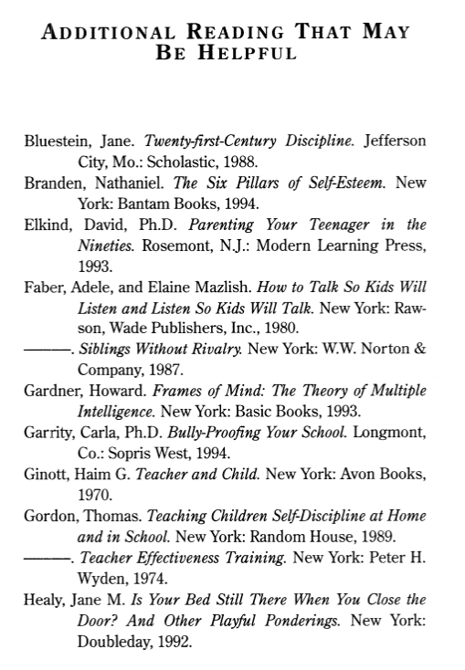Faber, A., & Mazlish, E. (1996). *How To Talk So Kids Can Learn*. New York, New York: Fireside.

**Appendix C** (Part III)

****

**What Is PZ?**

[**https://www.youtube.com/watch?v=swRzk2qFKeU**](https://www.youtube.com/watch?v=swRzk2qFKeU)