Parent Involvement Brochure  
Diana Stein

ADMIN/533

July 17, 2017

Dr. David Berry

**Introduction**

Shared decision making that includes multiple points of views and input helps school administrators guide the growth of the school, uniting the people to the vision, and gaining momentum in the process. The school vision, and understanding the school community in context of all students’ needs, is better understood by those affected by the changes when they are part of the process of decision making from the onset. When Parent Partners and community members are encouraged to get involved in their local schools through volunteering and becoming active members of the learning community, the opportunities for growth in all areas of development and academics are exponentially higher.

The purpose of these two brochures is to provide:

* community involvement opportunities for families within the school and the surrounding area,
* an explanation of the instructional initiatives at the school, and
* a list of activities that parents can become involved with at The Classical Academies.

**\*Please note:** *Pages three and four are to be read as one brochure, the following pages (p. 5-6) are a second tri-fold brochure.*

**Brochure 1**

**p.4**

**(Inside flap, right) (Back) (Front)**

**p. 5  
 (Inside)**

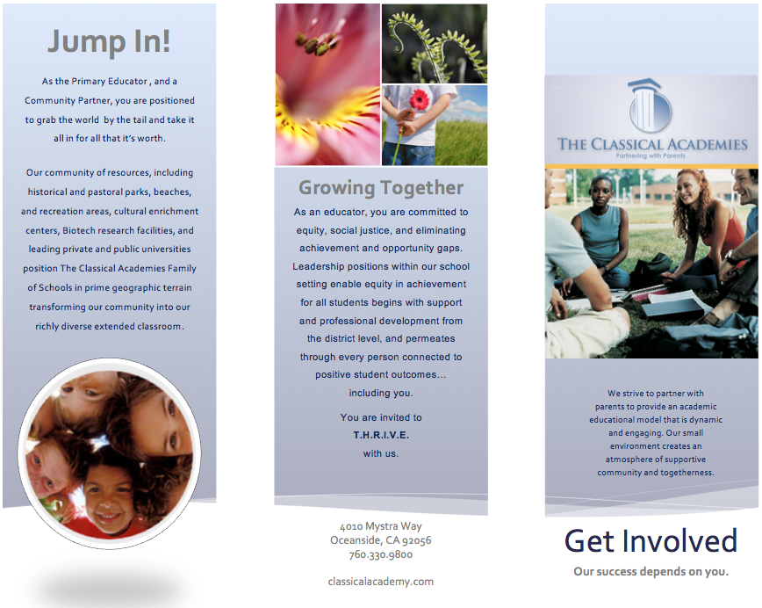

(Images and text paraphrased from: Classical Academy, 2017)

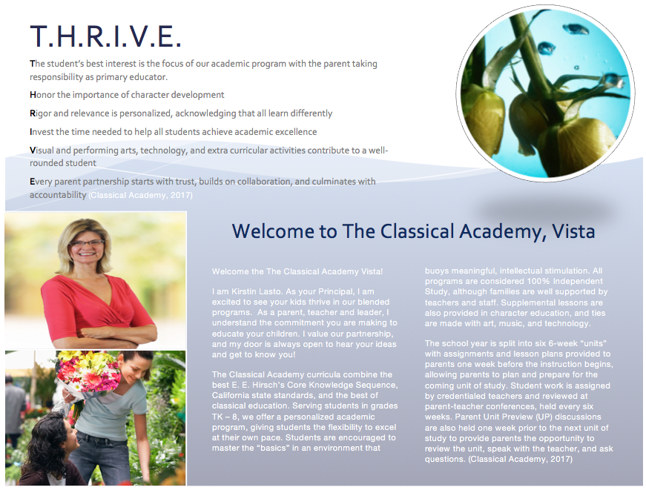

(Images and text paraphrased from: Classical Academy, 2017)

**Brochure 2**

**p.7**

**(Inside flap, right) (Back) (Front)**

**p. 8  
 (Inside)**

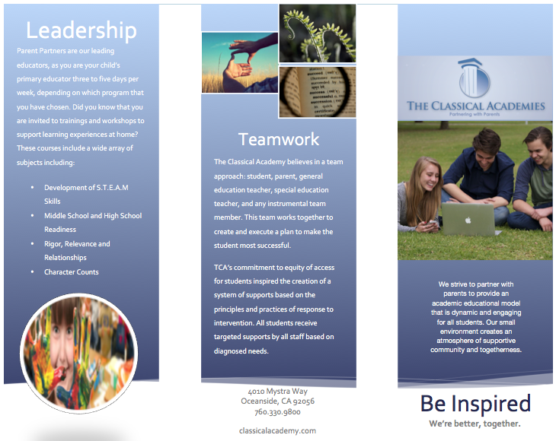

(Images and text paraphrased from: Classical Academy, 2017)

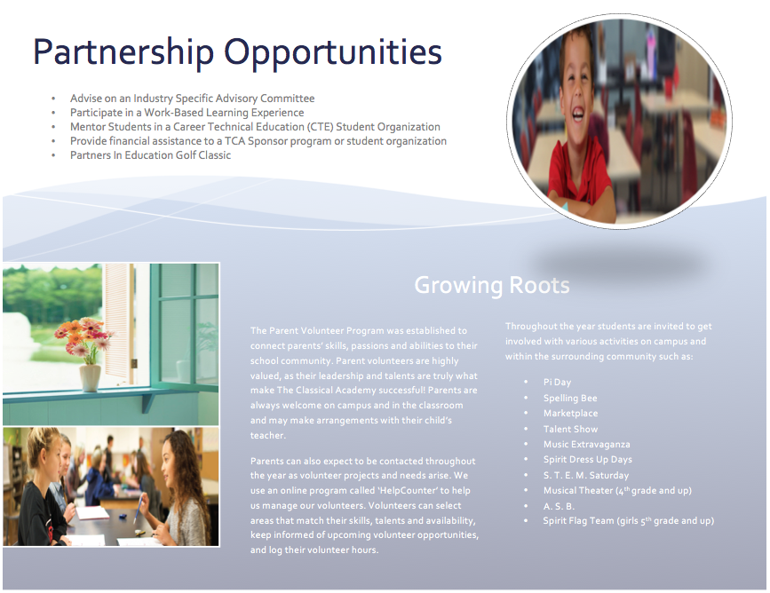

(Images and text paraphrased from: Classical Academy, 2017)

**References**

Hall, P., & Simeral, A. (2008). *Building Teachers' Capacity for Success* . Alexandria, Virginia: ASCD.

Jackson, R. (2013). Formative classroom walkthroughs: Instructional leadership for excellence in every classroom. Alexandria. VA: ASCD

Moss, C., & Brookhart, S. (2015). *Formative classroom walkthroughs: How principals and teachers collaborate to raise student achievement*. Alexandria, VA: ASCD.

Pinchot, M. m., & Weber, C. c. (2016). We’re all in this together. *Journal Of Staff Development*, *37*(5), 42-45.

The Classical Academies. (2017). *The classical academies.*Retrieved from https://classicalacademy.com/leadership/