Professional Growth Needs Assessment  
Diana Stein

ADMIN/540

August 21, 2017

Debra Dinowitz

**Introduction**

The new curriculum is community. This requires tapping into knowledge and being open to suggestions that benefit everyone, including learning from parent partners.   
The purpose of this paper is to identify professional growth needs of teachers and staff at The Classical Academy, Vista. As leaders, we must first assess the present performance level expectations and then identify the areas of strength, and the areas of need, in order to plan for meeting those expectations.

Through the results of the data that has been collected and analyzed from 15 of the teachers at TCA, Vista,through the Professional Growth Needs Assessment (please see *Walking the Walk Survey* in Appendix A)professional growth goals of teachers have been identified. Within the analysis embedded in this paper you will find identified areas of focus, such as:

* using technology within lessons,
* strategies for English language users,
* cooperative learning,
* assessment,
* leadership development,
* and professional development.

**Professional Growth Needs Survey Results Analysis**

I chose to use Google Forms as my format to gather information from teachers to complete, because of the ease of use and automacity of analysis. Additionally, I printed out paper versions of the same survey for the teachers’ added convenience on the same day that the email request was sent. It is revealing to note that one hundred percent of the 15 teachers who responded by the given time constraints did so selectively by using the online survey that was made available via a link sent by email within six hours or less of receiving the survey request. To boost motivation, I added a ten-dollar gift card to Barnes and Noble as a raffle prize as incentive for all to participate. Through this unified response I realize the impact that technology can have in bringing authentic responses into our learning community to engage staff in meaningful data collection and cooperative learning within very short time frames.

### As a result of acquiring the knowledge from the survey, here are the steps that I will conduct when considering my community’s readiness:

* Within my school or community, who might have the skill and know-how to be the point person for building partnerships? (Edutopia, 2017)
* What barriers could get in the way of connecting my students with local partners to tackle challenges together? How could I overcome them? (Edutopia, 2017)
* How might I invite diverse stakeholders to join the conversation about school change?  
  (Edutopia, 2017)
* How will my school or system prepare teachers to be agile curriculum designers and facilitators of real-world learning? (Edutopia, 2017)

### Collaboration in learning will benefit all learners. The benefits of collaboration with locals to deepen learning in the classroom include:

### Opening School Doors to the Community

### Involving the Community

### As a result, Parent Partners and the entire staff realize that:

#### 1. It’s GOOD to ask for help

#### 2. Everyone has something to offer

3. Making learning fun matters   
(Edutopia, 2017)

We are stronger collectively, providing deeper knowledge and resources than we could individually. Teaching is a partnership that requires each of us to remain flexible, while guiding our students to see the relevance in their learning, develop confidence, and make contact with role models within their communities. These relationships will engage all stakeholders in practices that will foster and promote positive change while attending to current learning goals. According to Currie (2015):

Online communities serve as a gateway for parents and schools to stay connected. There needs to be an expectation that teachers utilize these web tools to make learning relevant and accessible for students. Schools should provide information on their website about using these interactive websites.

In my experience I have witnessed some parents who do not want their children to have a presence online. For this reason, when we have a school blog the students first names are used in isolation and they do not have pictures of themselves or their likeness posted anywhere online. Privacy is preserved even though we are opening up our classroom to the global community. Parents who need added support are invited to Schoology trainings hosted by our schools, but as for guidance with online applications like Khan Academy and Google drive, parents are first lead to online tutorials before consulting with their child’s teachers.

This is an area of need that could be filled with parent skills training workshops in the evenings, or through a Saturday workshop series. The single most urgent area of need that was identified by the teachers who participated in the survey was offering parent trainings for specific subject-areas/growth transitions (e.g., Reading, Algebra, Geometry, Scientific research, general parenting workshops, etc.). This is in direct correlation with our SBAC testing results for mathematics, and is an identified area of need by most middle school students. Many parent partners have stated to that they are uncomfortable teaching anything beyond basic math. *Math FUN-damentals for Middle School* is a training that I will plan on organizing as my first parent workshop event this fall.

Any opportunity that you have as a school to invite parents into the system and make them a part of your school culture, the more it improves the student’s learning (Currie, 2015). Teachers who need additional support for broadening their depth and breadth of use of technology for teaching and assessment have multiple means of moving their knowledge ahead. The survey results indicate that the teachers would rather work with an Instructional Coach instead of being part of a webinar or professional development workshop. Knowing this information provides me the opportunity to personally plan to meet with each teacher as I re-introduce myself as his or her Instructional Coach. The survey also indicates that the teachers are highly self-reflective. I will anticipate allowing plenty of room for autonomy, as desired, as they work toward their individual goals.

A communication plan to build our areas of need will be put into place, promoting our product through multiple means, and seeking out our teachers as well as target parents. This is done through tapping into knowledge and being open to suggestions benefits everyone in the long run (Currie, 2015). This includes tapping into the strengths of all stakeholders. As such, we are forming committees this year at our school sites that require participation by all staff members that exceed the goals and expectations of their employment contract. Each team member has been asked to commit time to a cause of their choice, providing them a forum to contribute to our collective good through engaging their natural skills and abilities.

Curry also notes that it is unnecessary to differentiate between *involvement* and *engagement*; the point is how crucial it is for parents to be active in their children’s education. However the contribution is delivered—whether it is through social media or physically helping out with a school event—we need parents to contribute. The more that parents contribute, the better off all school stakeholders are in the long run. Acknowledging parent contributions is important as well and goes a long way to maintain a relationship built on trust and respect (Currie, 2015).

**Conclusion**

Leadership that is connected to those whom we serve as Teacher Leaders is most likely to build community relations. Analysis of the responses given reveals that the struggles between change and resistance, inequity and balance, and the perceived value of Professional Development is viewed differently by individual teachers. Which ever cause that one chooses to commit to in the end, it is our common goal to support learning for all learners by whichever means possible; intrinsically this includes supporting behavioral development, as well as equity in the socio-emotional needs of all learners.

As community partners we prepare to meet the challenges that our collective students face, while shifting our knowledge base from the role of managers to include effective instructional leadership (Dinowitz, 2017). While it is impossible to be an expert in all of the facets that make a school run at its optimal performance, leadership is well-positioned to unify all stakeholders, by entrusting their skills and talents to the fullest, to drive learning forward for all learners that is free from all biases.

**References**

Center for Educational Leadership, University of Washington. (2017). *5D+™ readiness assessment: getting ready for teacher evaluation.*Retrieved from http://info.k-12leadership.org/download-the-5d-readiness-assessment?_ga=2.229621788.1648212724.1502946996-1511578700.1502946996

Currie, B. (2015). *All hands on deck: Tools for connecting educators, parents, and communities.* Thousand Oaks, CA: Corwin

**Edutopia.com (2013).  *Learning partners: co-teaching with community experts.* Retrieved from https://www.edutopia.org/practice/learning-partners-co-teaching-community-experts**

Fill-A-Belly. (2017). Retrieved from http://www.christianvolunteering.org/org/fill-belly.jsp#fq=content_type:opportunity

San Marcos Chamber of Commerce. (2017). Charity Wings. Retrieved from http://www.sanmarcoschamber.com/list/member/charity-wings-art-craft-center-7367n http://charitywings.org

Solutions for Change. (2017). Retrieved from http:// http://solutionsforchange.org/who-we-are/

Stein, D. (2017). *Walking the walk survey.*Retrieved from https://docs.google.com/forms/d/1PJ3KM56nN7f7cG4EneDjJTvOHgW9DiBzbkO_5oAjLO0/edit#

Stein, D. (2017). *Walking the walk survey results.*Retrieved from https://docs.google.com/forms/d/1PJ3KM56nN7f7cG4EneDjJTvOHgW9DiBzbkO_5oAjLO0/viewanalytics

 Surfrider Foundation. (2017). *Surfrider foundation.*Retrieved from https://sandiego.surfrider.org/bp/

The Classical Academies. (2017). *JumpStart conference.*Retrieved from https://classicalacademy.com/communityengagement/jumpstart-conference/jumpstart-keynote-speaker/

**Appendix A**

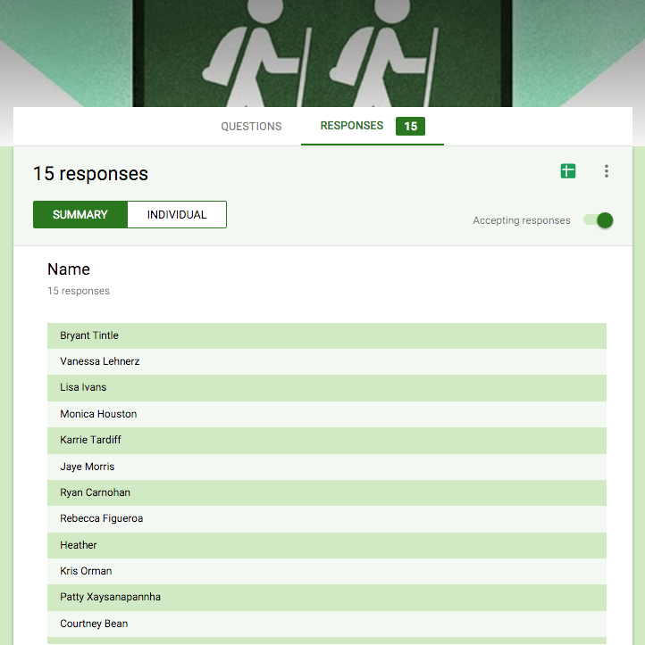



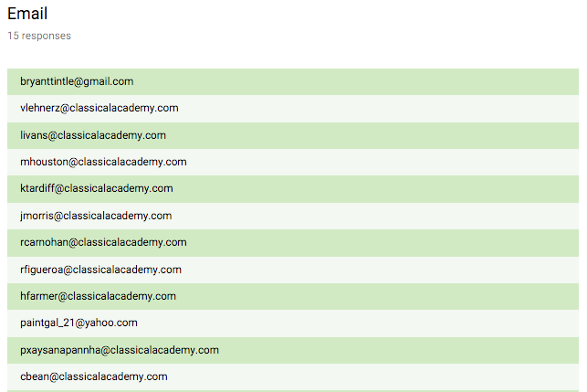



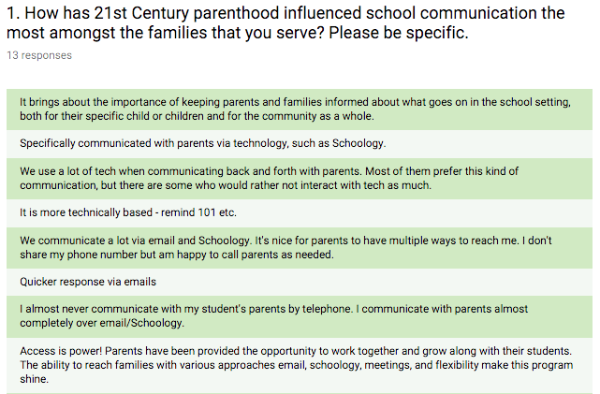

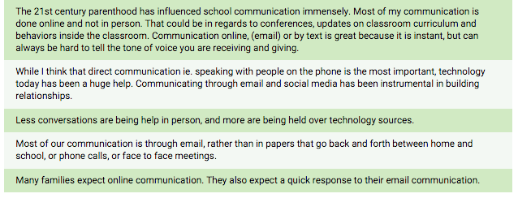

Schoology, seesaw

Remind: A program that uses text messages without revealing the teacher's phone number.

I found it surprising that the staff of teachers surveyed did not focus communication on the wealth of online resources available to Parent Partners to support them as they educate their children. Technology has provided schools and parents with many options to communicate and disseminate information related to a child’s progress. Student information systems (SIS) provide parents with access to viewing grades. Most of the teacher’s responses focused on how to communicate directly with each other, versus using technology to communicate/monitor student academic progress. This is mostly because the students do not get letter grades until seventh grade, and ongoing progress is not posted in Schoology until middle school. Upon reflection I could have written the question differently to specifically include responses about using technology as a means for parents to be more involved in students’ academic progress.

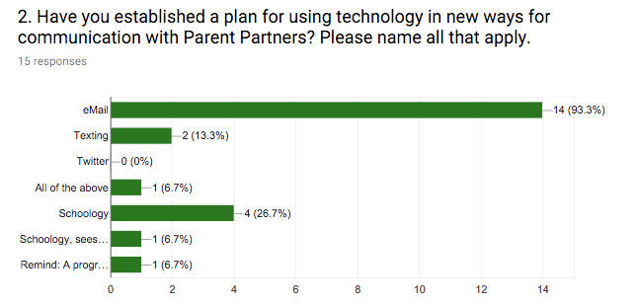

Google Drive has transformed the way our school and many schools now communicate important information to stakeholders in a variety of situations. Google resources are very efficient ways to address the needs of children, reducing the time and effort involved in getting everyone on the same page (Currie, 2015).

#### 

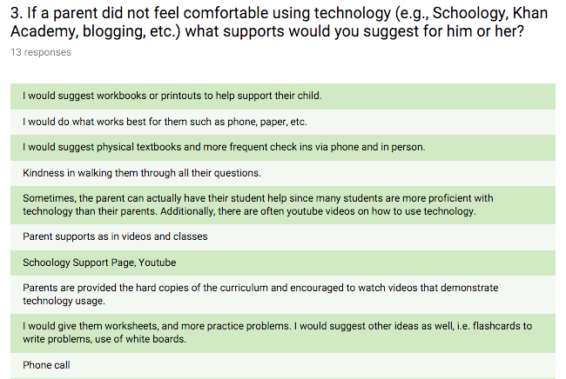

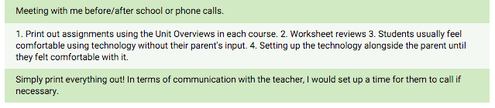

#### According to Currie (2015),

Online communities serve as a gateway for parents and schools to stay connected. There needs to be an expectation that teachers utilize these web tools to make learning relevant and accessible for students. Schools should provide information on their website about using these interactive websites.

Many schools and classroom teachers are taking advantage of online tools to stay connected with stakeholders. Group-based anonymous text messaging services, such as Remind 101 and Celly allow users to communicate important information while preserving their personal information. We are positioned to implement social media to keep stakeholders informed. We understand that users do not have to register to use such services as Twitter, Facebook, and Pinterest. District wide we provide access to our social media feeds that users can simply click and then follow to stay current with events. Other helpful forms of web communication include electronic mailing services and instant alert systems.

In my experience I have witnessed some parents who do not want their children to have a presence online. For this reason, when we have a school blog the students first names are used in isolation and they do not have pictures of themselves or their likeness posted anywhere online. Privacy is preserved even though we are opening up our classroom to the global community. Parents who need added support are invited to Schoology trainings hosted by our schools, but as for guidance with online applications like Khan Academy and Google drive, parents are first lead to online tutorials before consulting with their child’s teachers. This is an area of need that could be filled with Parent skills training workshops in the evenings, or through a Saturday workshop series.

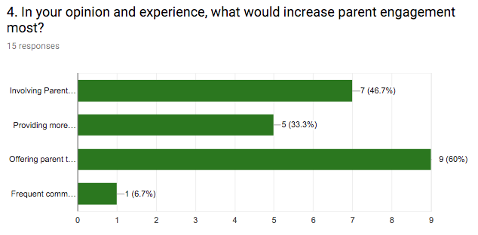

Involving Parent Partners with the school site more.

Providing more opportunities for parents to have their voice heard.

Offering parent trainings for specific subject areas/growth transitions (e.g., Reading, Algebra, Geometry, Scientific Research, general parenting workshops, etc.) **60%**

Frequent communication with parents about what is happening in the classroom, and opportunities to participate.

* From providing grade-level breakfasts to securing funding for the purchasing of innovative technology, the parental role is a powerful presence in our school environment. During these meetings, the school representatives also make it a point to highlight important happenings and relevant information. It is critical to take every opportunity to tell your school’s story accurately, before somebody else presents an inaccurate story (Curie, 2015).
* Any opportunity that you have as a school to invite parents into the system and make them a part of your school culture, the more it improves the student’s learning (Currie, 2015).
* A communication plan put into place, promotes our product through multiple means, and seeks out our target parents. This is done through tapping into knowledge and being open to suggestions benefits everyone in the long run (Currie, 2015).
* Parents are invited into the school network at every opportunity and tapping into their unique skill sets so that ultimately students benefit from that knowledge and experience in this instance, it is unnecessary to differentiate between involvement and engagement, the point is how crucial it is for parents to be active in their children’s education. However the contribution is delivered—whether it is through social media or physically helping out with a school event—we need parents to contribute. The more that parents contribute, the better off all school stakeholders are in the long run. Acknowledging parent contributions is important as well and goes a long way to maintain a relationship built on trust and respect. Schools can signal credit to parents in a variety of ways: a heartfelt conversation, public recognition, a simple handwritten note, a Tweet, Facebook post, or just a plain thank you demonstrates to parents that they are considered an important part of the educational process (Currie, 2015).

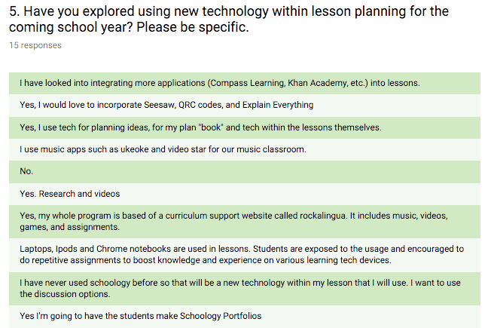

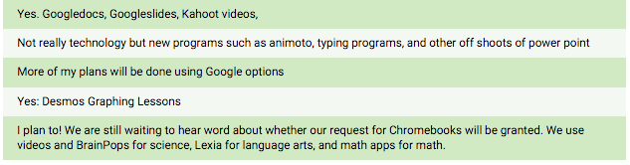

**Reading and Writing Resources:** In regards to reading, writing, mathematics, or some other subject, we know that there are an abundance of resources available. For example, blogging is a great alternative for students who don’t have a passion for writing entire reports. The authentic, age appropriate audience that is provided by those who share the link for collaboration for the blog (Currie, 2015).

**Math Resources:** Online programs like Khan Academy provide students with instruction at their own pace. Children can also benefit from screen casting programs (web based screen recorders), such as Educreations, which facilitates the recording and sharing of interactive lessons so that students can create their own tutorials and learn from others as well. (Currie, 2015)

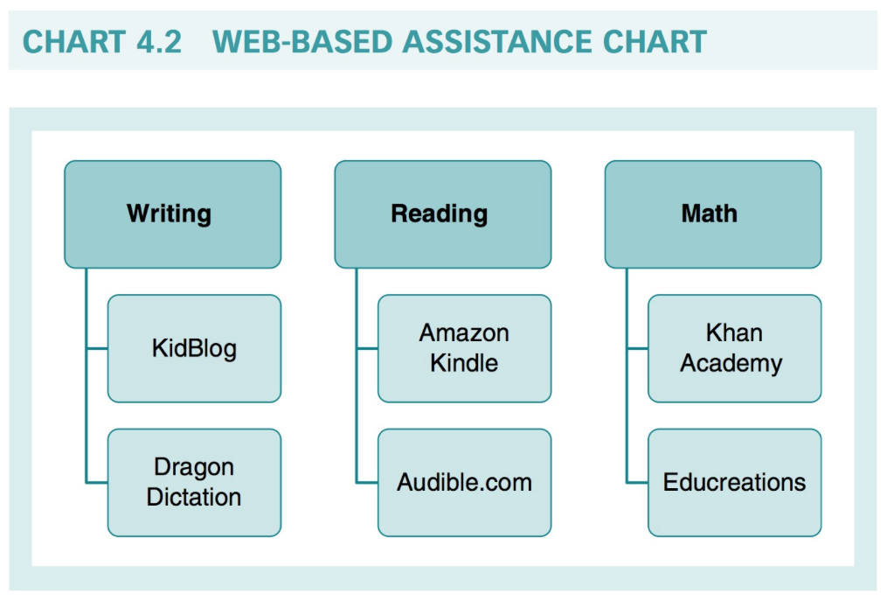

(Currie, 2015)

### Collaboration in learning will benefit all learners. The benefits of collaboration with locals to deepen learning in the classroom include:

### Opening School Doors to the Community

### Involving the Community

### As a result, Parent Partners and the entire staff realize that:

#### 1. It’s GOOD to ask for help

#### 2. Everyone has something to offer

3. Making learning fun matters   
(Edutopia, 2017)

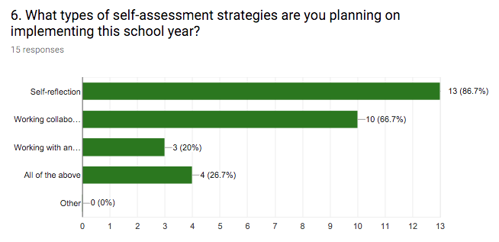

**Self-reflection: 86.7%**

Working collaboratively with peer partner.

Working with an assigned coach/mentor.

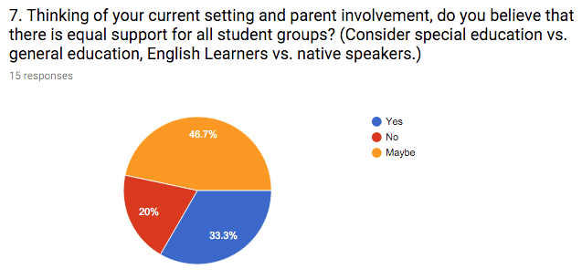

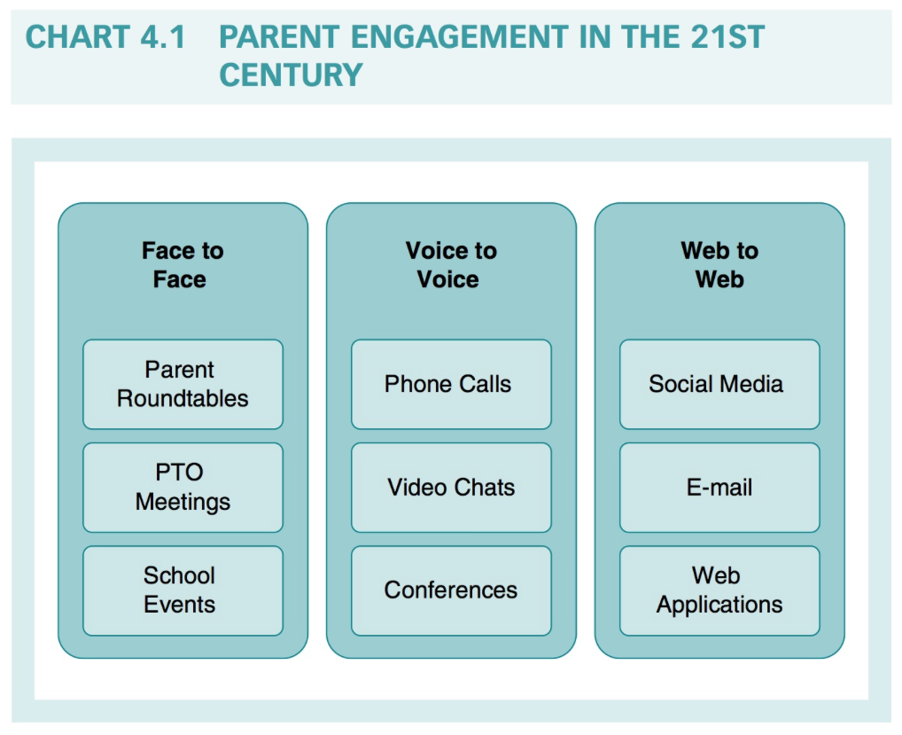

(Currie, 2015)

In my experience, teachers often provide the parents of ELL children their cell phone number in order to stay connected and to reassure them that they will check in from time to time. Looking for ideas and best practice resources for ELLs? Look no further than the #ELL hashtag on Twitter. Renowned author and educator Larry Ferlazzo has an outstanding blog full of articles and information related to meeting the needs f English Language Learners. Finally, check out the WIDA (World- Class Instructional Design and Assessment) website for professional development resources aimed at educators who are looking for innovative ways to make learning fun and relevant for ELLs. (p 41)

The students and their contributions to the discussion only added to the comprehensive perspective that our school community received. Equity of participation from diverse groups demonstrates the uniqueness of our school and our culture. Tapping into parent resources is a critical component of a school's mission to promote the success of all students (Sinanis & Sanfelippo, 2015).

Creating a system of intentional Impact is something that will definitely include being mindful of our words and our actions towards everyone that we meet on a daily basis. Everything speaks, so taking the extra step to be responsive, instead of reactive goes a very long way in uniting everyone and growing our vision into our reality.

When a child struggles, the best thing that schools and parents can do is to set up a meeting. Face-to-face or voice-to-voice communication empowers all parties to unify and agree on what is best for the child. Regardless of whether the meeting is formal or informal, a plan needs to be put into place. Guidance counselors and specialized child study team members (e.g., in New Jersey) are an integral part of this process and are a school’s and parents best resource. The only option for schools when dealing with a child’s learning or behavioral issues is to exhaust all options. Embracing parent engagement and truly partnering with families goes a long way to promoting student success. (Currie, 2015)

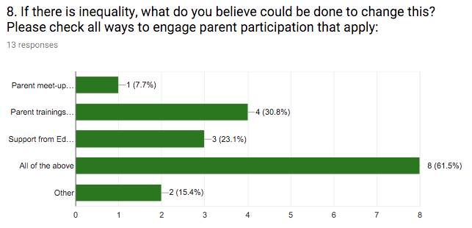

Parents must know that it is perfectly reasonable to have their voices heard in the educational decision of their child. Over time, parent voice has become prevalent and more and more the norm in organizations, such as the PTO, Boards of Education, and parent volunteer work behind the scenes. The hard work and dedication of parents is critical if schools are to be successful in meeting the needs of learners. Whenever there is a concern or an issue that needs to be addressed, everyone should feel that school personnel are only an impromptu visit, phone call, or e-mail away. (Currie, 2015)

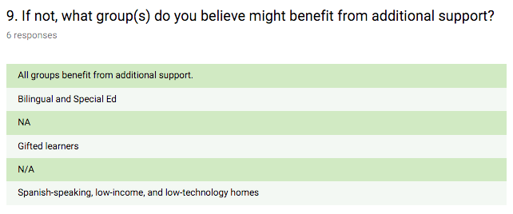

Perspective is everything, and administrators, teachers, and support staff must be kept informed if something is not right. Staying up-to-date and current on educational trends and best practice resources is critical. Various website and social media platforms provide parents with an avenue to express their concerns. Blogs, for example, provide readers with practical knowledge from people who are on the front lines of parenting and education. Online parent portals that can be found on the Department of Education’s website and the Discovery Education website are full of ideas and programs that promote a family learning environment.

It is important to remember that leveraging the power of social media is also a means to connect with the best minds in the business and let your voice be heard on important educational issues. (Currie, 2015)

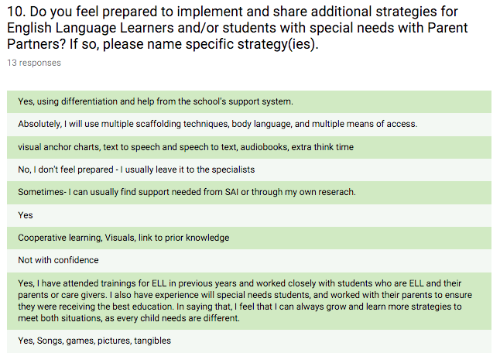

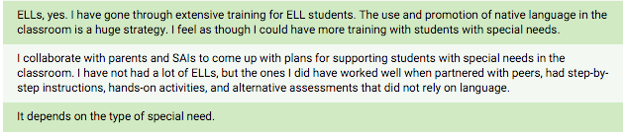

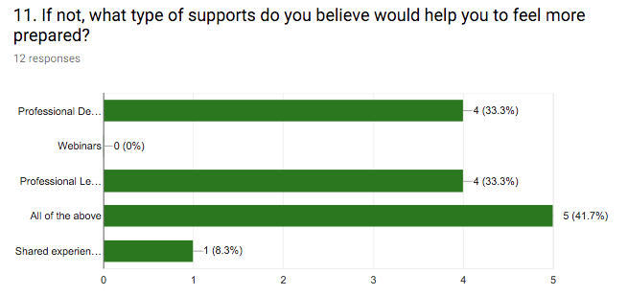

Professional Development workshops

Professional Learning Community (PLC) building/bonding

Shared experience with what works

**In my role as Instructional Coach this year I will make certain that supports requested will be delivered in a timely manner.**

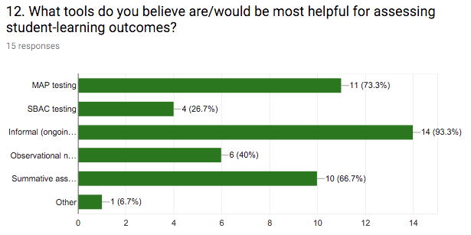

These results were surprising and revealing of the perceived value that SBAC Testing holds in the perception of the teachers. With so much funding attached to the SBAC results it is important that this format of analysis and data collection of student performance is given additional attention and value amongst staff and parents alike.

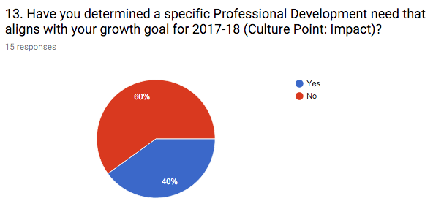

These results are not surprising, since we have just begun our school year this week. Teaching Performance/Growth Goals are not expected until the end of September. Since 40% of the staff that responded already have their Professional Development goals firmly in place, it is reasonable to estimate that they will have questions about meeting those goals formulated early in the fall semester. As the Instructional Coach I will make a calendar for when I plan to work with each teacher individually to set up support systems to help them to meet their target goal(s).

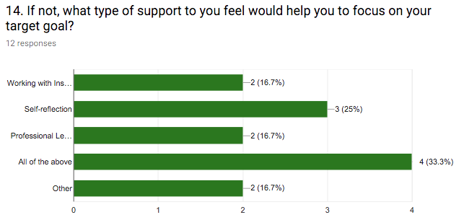

This graph illustrates that the first choice for professional Development by the teachers is self-reflection (25%). Working with an Instructional Coach, with Professional Learning Communities, and “other” each scored equally (16.7%). This informs me that the staff would like to implement a diverse range of ways to self-monitor professional growth. It would have been interesting to know what was meant by “other.” In the next survey that I write I will add a text field along with “other.”

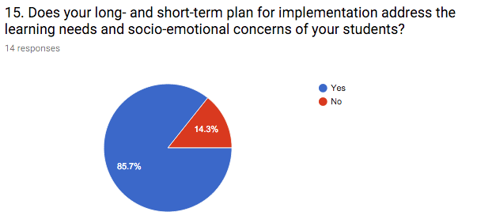

I found the response of “no” to this question to be surprising. As we plan and implement instruction we must always be aware of the socio-emotional needs of all of our students. As we determine the principles of educational equity and diversity, we must be aware of continually building in strategies for creating positive, safe, and supportive learning environments for all student groups.

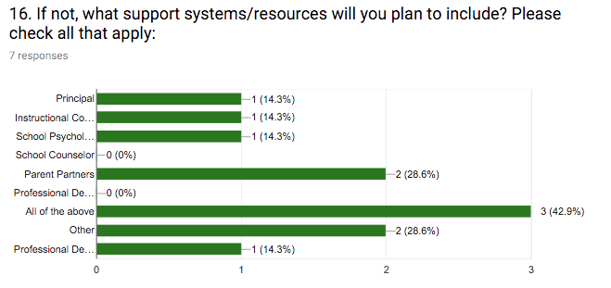

The results to this question are insightful to the degree of respect that teachers have for each of the leaders listed in this list. Consensus building and shared-decision making do not happen in a vacuum. I was surprised to see that the category of professional Development received no votes, however it was implied as valuable as it was included by the “all of the above” response (42.9%). Judging from the results, the staff does not wish to be involved in online webinars, workshops, or read books. The message here is that they would rather be coached on specific points, rather than doing the research/homework individually. Once again, it would have been insightful to have added a text box alongside the “other” option box.

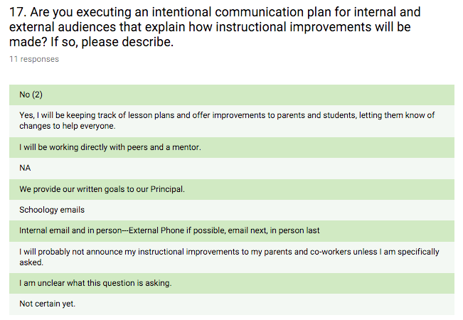

This question was not as clearly written as it could have been. Specifically, it was intended to address methods for intentional (internal and external) communication about improving instructional practices. Since we are a hybrid homeschooling model, it is important that we communicate strategies and best practices with our parent partners, as well as with our colleagues. The results to this question tell me that the teachers who responded are somewhat private and/or don’t understand the purpose of the question clearly.

With so many ways for our parents to get actively involved (e.g., participating in the planning of science fairs, being part of educational programs that bring learning to life, school dances, movie nights, and grade level breakfasts, etc.) we each know that there are plenty of ways to become active at home with our children’s learning. Simply asking children specific questions about what they learned, and how they know if they understood the main objective, is very important. According to Currie:

The proverbial question, “How was school today?” is no longer effective. Tapping into your school or district’s SIS (student information system) is a great beginning. What if your child’s school doesn’t have these sorts of opportunities? Start pressing the issue and ask why? In the year 2014, there is no reason that schools and parents should not be connected in a variety of ways (real and virtual) that ultimately promote the success of all students. (Curry, 2015)

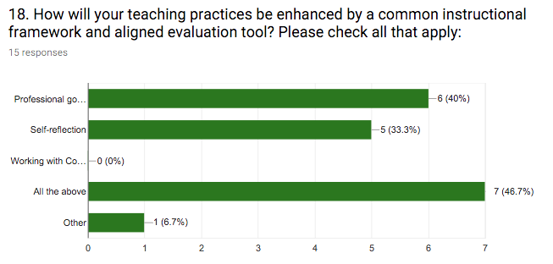

Professional goal setting, coupled with self-reflection, is by far the most preferred way to grow our practices. Teachers did not respond to “working with coach”, but this was implied with the “all of the above” response (46.7%).

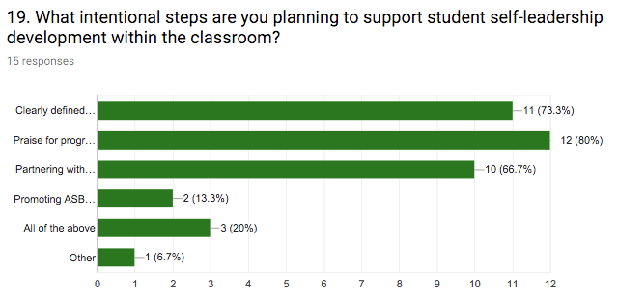

Clearly defined classroom expectations for student behavior (73.3%) and praise for progress (80%) scored highest, followed by partnering with parents more closely (66.7%). It is interesting to note that “all of the above” only received a score of 20%. This indicates that teachers value the skills learned and practiced inside of the classroom higher than those communicated and then reinforced at home.

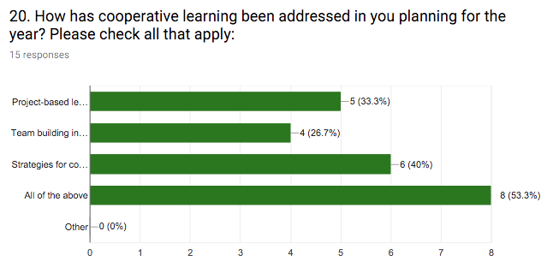

Project-based lesson planning

Team building inside of and outside of the classroom

Strategies for collaboration and higher critical thinking

All of the above **53.3%**

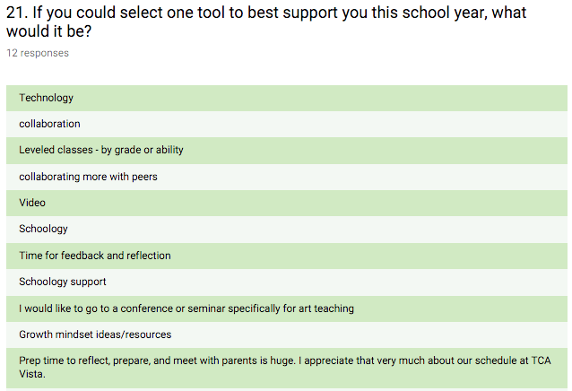

Macintosh HD:Users:diana:Desktop:Screen Shot 2017-08-19 at 10.48.26 AM.png



**Appendix B**

Programs in place to address the changing needs of our community and school population. Hands-On opportunities for students and staff to get involved that currently exist include:

* **Fill-a-Belly:** a relational homeless dinner hosted once a week in Carlsbad and Encinitas CA. We value, good food, empowerment not dependence, respect and fulfilled lives. We feed around 200 people a week and volunteers eat with our homeless guests. Our goal is to break down the "buffet line barrier" found in many homeless outreaches.  Please see:  
  <http://www.christianvolunteering.org/org/fill-belly.jsp#fq=content_type:opportunity>
* **Solutions for Change:** From their original 300 sq. office in downtown Vista, they began casting a vision around solving family homelessness. The vision was different in that it did not include more shelter beds, feeding programs or traditional human services, but rather an audacious plan to create access to permanent solutions using a hybrid model that the couple developed. All the parents being helped would work, pay rent, attend onsite workshops and classes and were engaged in a dynamic coaching system. The model, now known as the Solutions University, blends affordable housing, educational opportunities, employment training and health related solutions all within one cohesive strategic partnership. There is but one goal: work with this community to solve family homelessness for kids and communities, permanently. By doing so, the future for kids could be transformed.   
  Please see: <http://solutionsforchange.org/who-we-are/>This coming school year I am planning on adding two more organizations to our radar:
* **Charity Wings:**  The mission of the Charity Wings Art and Craft Center is to be an inspiring place for people of all ages to gather, give back, and create; as well as to partner with other charities to give free classes to those who can benefit from the hope, happiness, and healing that Art can provide. As part of our mission, Charity Wings partners with other charities serving the disabled community, low income families, military/veterans, various support groups and more. Please see:

<http://www.sanmarcoschamber.com/list/member/charity-wings-art-craft-center-7367n>

[http://charitywings.org](http://charitywings.org/)

* **Surfrider Foundation:** Preservation and restoration of San Diego County’s natural beaches, wavecut platforms, nearshore environment, and sandstone bluffs is important. Our goal is to preserve of San Diego's remaining natural coastline and restore the coast to its natural, unarmored state. Please see: <https://sandiego.surfrider.org/bp/>

My role as the ASB Director this school year will be varied. I am planning on tapping into the students’ hopes and goals for where they feel that they will be best positioned to serve. With a variety of ways available to give back, I anticipate the momentum to grow to include other students, parents, staff, and community members in these amazing and powerful programs and charitable organizations.  I am planning on launching school wide campaigns using social media with my ASB kids to get the momentum moving! We have a very dedicated bunch of students and parents. Now it’s time to spread the word into the neighboring business community.