Community Analysis of Data  
Diana Stein

ADMIN/530

March 6, 2017

Debra Dinowitz

Diana, as you are outside of the public system and this was a new concept to you , I congratulate you on searching through the LCAP for Poway and locating all of this information . You did an excellent job and I think in the long run since this is an integral part of how district's set goals and are funded it made sense for you to examine it. Great work. -- Dee 12/12

**Introduction**

The data-growth growth plan that is analyzed herein is the Local Control and Accountability Plan (LCAP) for Poway Unified School District in San Diego, California. According to “Poway Unified School District LCAP Reports” (2017),

(The expectation of this plan) is to provide details regarding the local educational agencies’ (LEAs) actions and expenditures to support pupil outcomes and overall performance pursuant to Education Code sections 52060, 52066, 47605, 47605.5, and 47606.5. The LCAP and Annual Update Template must be completed by all LEAs each year.

Poway continues to use data (both qualitative and quantitative) from multiple sources to inform the goals and targets that were set to close achievement gaps as well as to ensure that our students are engaged in a rigorous educational experience. These data metrics and community feedback have been and will be used to inform the ongoing goals and strategies aligned to the LCAP Priorities and described in this plan. (“Poway Unified School District LCAP Reports”, 2017)

**Performance Data Overview**

The plans are transparent to the public, after input from the public was provided to ensure that the money received is serving the needs of students. The school and/or district serve the needs of the students with the money it receives and the LCAP details how this is done. The state of California mandates that school districts seek parent input on the LCAP.  Parent meetings are held and input is requested through surveys to aid the district in gathering information to author the LCAP. The input sought from the public is based on the 8 State Priorities of the LCAP. Performance data that will be included is:

* **Student Achievement**Success measured through test scores,English proficiency,and college readiness.
* **Implementation of Common Core state standards**Transitioning to the new academic standards
* **Course access**Ensuring that all students have access to classes that prepare them for college and career, regardless of where they live and/or attend school.
* **Basic services**Well-maintained facilities with necessary materials that are safe and in adequate or better working conditions.
* **Student Engagement**Focused on providing engaging learning environment utilizing strategies and tools to reach and teach all learners where they are in their personal learning path.
* **School Climate**Provides a nurturing, safe, positive, and productive school environment that promotes academic success and character development through leadership programming. This is directly correlated with reduced suspension rates and behavior management.
* **Parent Involvement**Parents who are involved in the decision-making for school wide programming and academic progress of their own as well as other students   
  propel growth and momentum.
* **Other Student Outcomes**Areas affected by LCFF funding besides core academics and the areas listed above are the arts, physical education, and enrichment studies.

(Paraphrased from California Endowment, (YYYY))

The main objectives of this Community Analysis of Poway Unified School District’s LCAP Reports will be addressed within six categories, listed within this paper as subheads:

1. **What kind of performance data? (**Title and type of data used)

**How are they reaching these goals?**

1. **Data-Based Growth Plan**

**Data:** What data were used to develop these goals?

**Actions:** What actions or strategies are planned to reach this goal?

1. **Stakeholders:** What stakeholders are responsible for completing the planned actions or strategies necessary to reach this goal?
2. **Resources:** What resources are required to implement the planned actions?
3. **Cost:** What is the financial cost of implementing this plan, including the funding source?
4. **Evaluation:** What is the process for evaluating progress toward or completion of the goal?

**What kind of performance data? (**Title and type of data used)

**Goal 1:** Support high-quality teachers in their implementation of an articulated California standards-based curriculum, instruction, and assessment to ensure College and Career Readiness and Citizenship for all students,   
TK-12.

**Goal 2:** Smarter Balanced Assessment presents an ongoing focus on meeting the academic needs of all students, including underperforming student groups.

**Goal 3:** Strengthen safe, healthy, positive, and attractive learning environments and experiences for all learners.

**Goal 4:** Increase student and parent engagement in learning through enhanced community involvement, two-way communication, and partnerships with community businesses. (“Poway Unified School District LCAP Reports”, 2017)

**How are they reaching these goals?**

* Creating systems and structures that provide multiple pathways of learning and engagement to increase College and Career Readiness of our students and close the achievement gap for all subgroups.
* California continues to adopt core content, science (NGSS: Next Generation Science Standards) and English Language Development (ELD) standards and frameworks. Alignment of core, NGSS, and ELD instructional and supplementary materials, including intervention resources, with California State Standards and frameworks is needed as the state adopts each new content area.
* Researching supports and demonstrates that the physical, social, emotional, and behavioral health of each learner is a basic and critical for student learning.
* California Healthy Kids (CHKS) data, parent perception data, and community feedback via forums and surveys have identified the ongoing importance of the whole child and their mental and physical being in a safe learning environment. Data supports the need for ongoing systemic attention to anti-bullying, substance use/abuse and other social/emotional challenges that our students may face.
* Strengthening school site support in discipline and attendance by increasing the use of Positive Behavioral Intervention and Support (PBIS) and restorative justice practices K-12.
* Providing supports needed for students to successfully engage in school.
* In order to prepare our students for the 21st century global economy and multi-cultural society, it is important to provide learning opportunities that engage their passions and apply their core subject knowledge. Perception data gained from community forums and surveys identified areas of focus that include but are not limited to Athletics, Visual and Performing Arts (VAPA), Science Technology Engineering Arts and Mathematics (STEAM), Coding, and Robotics.   
  (“Poway Unified School District LCAP Reports”, 2017)

**Data-Based Growth Plan**

Data used to select the focus goals was guided by the following guiding questions:

1. What are the LEA’s goal(s) to address state priorities related to “Conditions of Learning”?
2. What are the LEA’s goal(s) to address state priorities related to “Pupil Outcomes”?
3. What are the LEA’s goal(s) to address state priorities related to parent and pupil “Engagement” (e.g., parent involvement, pupil engagement, and school climate)?
4. What are the LEA’s goal(s) to address any locally-identified priorities?
5. How have the unique needs of individual schoolsites been evaluated to inform the development of meaningful district and/or individual schoolsite goals (e.g., input from site level advisory groups, staff, parents, community, pupils; review of school level plans; in-depth school level data analysis, etc.)?
6. What are the unique goals for unduplicated pupils as defined in Education Code sections 42238.01 and subgroups as defined in section 52052 that are different from the LEA’s goals for all pupils?
7. What are the specific expected measurable outcomes associated with each of the goals annually and over the term of the LCAP?
8. What information (e.g., quantitative and qualitative data/metrics) was considered/reviewed to develop goals to address each state or local priority?
9. What information was considered/reviewed for individual schoolsites?
10. What information was considered/reviewed for subgroups identified in Education Code section 52052?
11. What actions/services will be provided to all pupils, to subgroups of pupils identified pursuant to Education Code section 52052, to specific schoolsites, to English learners, to low-income pupils, and/or to foster youth to achieve goals identified in the LCAP?
12. How do these actions/services link to identified goals and expected measurable outcomes?
13. What expenditures support changes to actions/services as a result of the goal identified? Where can these expenditures be found in the LEA’s budget?   
    (“Poway Unified School District LCAP Reports”, 2017)

**Data:** What data were used to develop these goals?  
Academic and performance standards will continue to be aligned with California State Standards in 2016-17, including ELD standards. The alignment requires teachers to participate in piloting and recommending the adoption of district wide resources, professional development in instructional practices aligned to standards, rewrites of high school courses, and exploring district wide formative assessments to inform instruction. The 2016-17 year will address the following core areas:

* Integrated Mathematics, 9-12
* Science, K-12
* English Language Arts with focus on Early Literacy, K-5 Reproductive Health (5, 7, and 9)
* Physical Education, TK-5
* Alignment of Literacy Standards is ongoing in all other content areas, including our Career Technical Education (CTE) courses, Languages other than English (LOTE), Physical Education, Visual and Performing Arts (VAPA), and Electives.   
  (“Poway Unified School District LCAP Reports”, 2017)

**Actions:** What actions or strategies are planned to reach this goal?   
Academic standards, pedagogical skills, instructional practice or student assessments identified by the growth plan

* Maintain staffing ratio/class size from 2015-16.
* New teachers will continue to participate in the Poway Professional Assistance Program (PPAP), which provides training, coaching, and evaluation on standards based instruction and assessments, student led goal setting, and technology integration. PPAP includes support for year 2 teachers needing to clear their professional credentials.
* In 2016-17, LSS will implement the multi-year plan that funds the integration of Physical Education, VAPA, and STEM curriculum throughout our elementary schools via the X-Ploration Model. This includes the integration of coding classes.
* A Task Force will develop a Visual and Performing Arts vision for our district with specific implementation in 2017-18 at the elementary schools and refinement of our secondary programs.
* Continue increasing the percentage of diverse certificated and classified staff serving our students by 1% each year.
* Professional Learning Leaders at each site to focus on RTI, school culture and technology integration. This includes supporting teachers in the design of rigorous and relevant lessons as well as development of implementation strategies.
* Continue to implement effective academic support structures and interventions that provide time and expertise for students to access during and beyond the school day.
* Advancement via Individual Determination (AVID) Intervention classes  
  Impact Teachers  
  Tutoring
* Before and after school programs  
  Required Title I school tutoring support services
* Implement strong practice in the areas of Culturally Responsive Learning Environments, Bullying Prevention, the benefits and challenges of Social Media, and Drug Education.
* Continue to work with district and site leaders and site staff and evaluate practices for Culturally Responsive Schools for both students and parents.
* Potentially implementing a new program on bullying, district wide, in 2018-19.
* Implementing a new program on drug education, district wide, in 2018-19.
* Continue to maintain safe school facilities.
* Continue to increase custodial, maintenance, and grounds staffing in order to meet routine, restricted maintenance requirements.

Continue to assist families experiencing homelessness through providing supports for school, referrals to community agencies, and additional resources as determined.   
(“Poway Unified School District LCAP Reports”, 2017)  
Interesting!   
**Stakeholders:** What stakeholders are responsible for completing the planned actions or strategies necessary to reach this goal?

All stakeholders (e.g., parents and pupils, including parents of unduplicated pupils and unduplicated pupils identified in Education Code section 42238.01; community members; local bargaining units; LEA personnel; county child welfare agencies; county office of education foster youth services programs, court-appointed special advocates, and other foster youth stakeholders; community organizations representing English learners; and others as appropriate) have been engaged and involved in developing, reviewing, and supporting implementation of the LCAP.(“Poway Unified School District LCAP Reports”, 2017)

**Resources:** What resources are required to implement the planned actions?

Student and school needs identified by the growth plan

Continue to increase opportunities for coursework and co-curricular experiences in grades K-12 which integrates academic subjects with relevant, challenging, technical and occupational knowledge. Through Career Technical Education (CTE) pathways, students will incorporate applied learning across disciplines preparing them for both college and career.

Continue working on the California English Language Development (ELD) standards in our classrooms, with support within and outside the school day including:

* Instructional Assistants
* Staff Development for Teachers and Instructional Aides
* Integration of common formative assessments to inform instruction for ELD students
* Community Learning Centers (for students/parents new to the US whose primary language is other than English)
* Parent Liaisons
* Continue to expand collaborative learning opportunities through multiple environments including online courses, tutorials, extension activities, and extended year.
* MyConnect (Canvas)  
  Online course development and delivery Exploration of other blended learning opportunities
* Pathways that integrate alternative programs to meet graduation requirements as well as to explore career pathways
* Continue to provide opportunities for coursework in grades K-12 which integrates academic subjects with relevant, challenging technical and occupational knowledge. Through Career Technical Education (CTE) pathways, students will incorporate applied learning across disciplines preparing them for both college and career.
* Continue to increase staff development in AP strategies as well as broadening equity and access to course work.   
  (“Poway Unified School District LCAP Reports”, 2017)

**Cost:** What is the financial cost of implementing this plan, including the funding source?  
(Please see Appendix A)

**Evaluation:** What is the process for evaluating progress toward or completion of the goal?

* 100% teachers with subject/s expertise
* Increase certificated and classified staffing diversity 1% until representative of student population
* Increase in student mastery of TK-12 mathematics and English Language Arts standards as measured by Smarter Balanced Assessments (SBA) and 2016-17 as a benchmark.
* Increase in the percentage of students who are conditionally college ready or college content ready in mathematics and English Language Arts standards as measured by Smarter Balanced Assessments (EAP-SBA), benchmarked from 2016-17 assessment data.
* Williams Act compliance (curriculum materials) as reported in the School Accountability Report Cards (SARCs)
* Alignment of curriculum, instruction, and assessment to new state content and ELD standards and frameworks
* Graduation rate increases by 0.1% each year, within five years; 0.2% for each underperforming student group
* Percentage of students who pass an AP examination with a score of 3 or higher will increase by 1.0% each year
* A-g rates increase by 2% each year; 3% for each underperforming subgroup
* CTE Course Completion rates increase by 2% each year; 3% for each underperforming subgroup
* ELL students: 82% achieve one year expected growth on CELDT
* SBA Scores in Mathematics and English will be analyzed for the establishment of district goals in 2017-18
* API Data will be analyzed for the establishment of district goals in 2017-18   
  (“Poway Unified School District LCAP Reports”, 2017)

**The Expectation Model**

According to “Poway Unified School District LCAP Reports” (2017),

Hargreaves and Fullan (2012) point out that transforming education is about building collaborative cultures, trust, and relationships. The actions taken by PUSD in response to LCAP have begun this process -- where inquiry and organizational learning are the drivers of improvement. As PUSD moves forward, this study has shown the importance of continuing to secure strong public engagement and creating educational partners who can work together to improve teaching and learning for all Poway students.

Meaningful engagement of parents, pupils, and other stakeholders, including those representing the subgroups identified in Education Code section 52052, is critical to the LCAP and budget process. Education Code sections 52060(g), 52062 and 52063 specify the minimum requirements for school districts; Education Code sections 52066(g), 52068 and 52069 specify the minimum requirements for county offices of education, and Education Code section 47606.5 specifies the minimum requirements for charter schools. In addition, Education Code section 48985 specifies the requirements for translation of documents. (“Poway Unified School District LCAP Reports”, 2017)

*Please see Appendix A (following reference page) for details on LCAP Year 1: 2016-17 to read expectations for measurable outcomes, actions/services, and budget expenditures.

**Conclusion**

In conclusion, each voice that took part in this important work is positively impacting the lives of the students that they are dedicated to guide in their educational as well as developmental paths. Poway Unified School District has included all stakeholders from the district level, to students and parents, and the community at large to successfully author their LCAP 2018 with transparency and excellent leadership. Providing details regarding the local educational agencies’ (LEAs) actions and expenditures to support pupil outcomes and overall performance pursuant to Education Code sections 52060, 52066, 47605, 47605.5, and 47606.5 creates trust that will build bonds that lead to long lasting community partnerships and educational excellence. Qualitative and quantitative data herein is merely an overview of the entire body of data collected on their school website for all stakeholders to access at will. Districts, school, families and communities that diligently work together will break achievement barriers, authoring a plan for a brighter future for all.

**References**

Bruce Sheppard Jean Brown, (2014). Leadership for a new vision of public school classrooms Technology-smart and learner-centered. *Journal of Educational Administration*, Vol. 52 Issue 1 pp. 84 – 96

 California Endowment. (YYYY). CA State's 8 Priority Areas for LCFF. Retrieved from http://www.healthhappenshere.com/what_are_8_priority_areas_for_lcff

Hargreaves, A. & Fullan, M. (2012). *Professional Capital: Transforming Teaching in Every School*. New York: Teachers College

Local Control Funding Formula Overview. (2017). Retrieved from http://www.cde.ca.gov/fg/aa/lc/lcffoverview.asp

Local-Control State. (2014). Retrieved from http://edglossary.org/local-control-state/

Poway Unified School District LCAP Reports. (2017). Retrieved from http://www.powayusd.com/en-US/District/District-Reports/LCAP

What is LCFF funding?. (2017). Retrieved from https://www.ed-data.k12.ca.us/Pages/LCFF.aspx

Appendix A

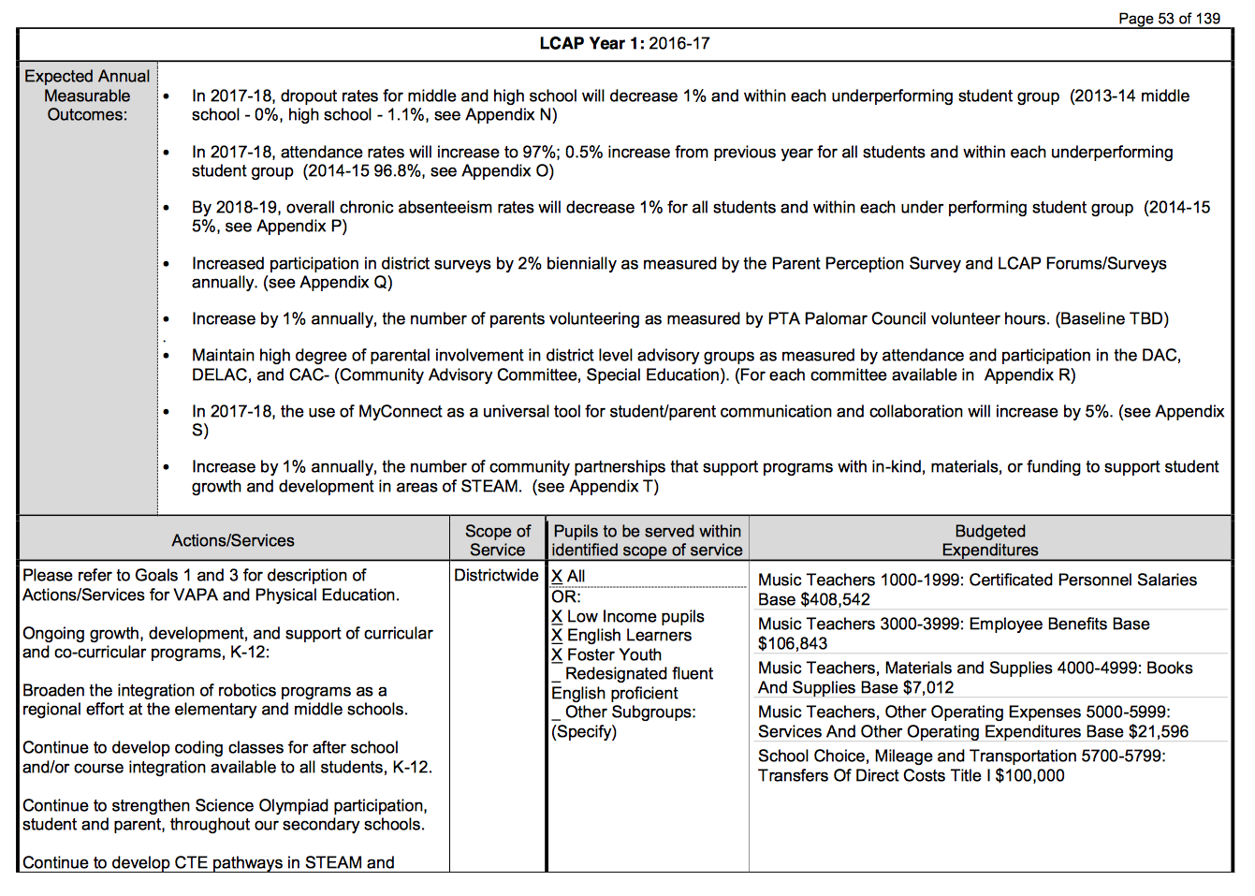

(“Poway Unified School District LCAP Reports”, 2017)

Outstanding job !

* Title and type of data-based growth plan (1)
* Authors of the plan (identify authors by role and not by full name)(1)
* Performance data used(2)
* Data used to select the focus goals(2)
* Student and school needs identified by the growth plan(3)

Academic standards, pedagogical skills, instructional practice or student assessments identified by the growth plan (3)

Conventions (1)

Full credit in all areas!