Vision Implementation

Diana Stein

ADMIN/510

July 18, 2016

Russ Cornell

\***Please note:** The contents of this paper were used to create a website.

<http://dianaartworks.wix.com/educator>

Please click on the **Activ8PositivityBlog** link on the BOTTOM right to view online,

or go directly to blog: <http://activ8positivity.blogspot.com/2016/07/leading-by-example-to-promote.html>

**CAPE #3:** Leading by Example to Promote Implementation of the Vision

**CAPE #4:** Sharing Leadership with Others in the School Community to Help Accomplish the Vision

**CAPE #5:** Promoting Implementation of K-12 Standards, Pedagogical Skills, Effective Instructional Practices and Student Assessments for Content Instruction

**CAPE #6:** Evaluating, Analyzing, and Providing Feedback on the Effectiveness of Classroom Instruction to Promote Student Learning and Teacher Professional Growth

**CAPE #7:** Demonstrating Understanding of the School and Community Context, Including the Instructional Implications of Cultural/Linguistic, Socioeconomic, and Political Factors

**CAPE #8:** Communicating with the School Community about School wide Outcomes Data and Improvement Goals

**Introduction**

“To passionately serve, respectfully communicate,   
and joyfully partner for student success” *– Vision, The Classical Academy (2014)*

The principal leads by example to promote the implementation of the shared vision united by shared expectations, ethics, and core values. Expectations of personal and professional ethics and values of the school include being open to a dynamic, collaborative, teacher-driven school improvement where teachers have the freedom to design and integrate their curriculum and practices. Innovate for the equity and advancement of all learners is to passionately serve, respectfully communicate, and joyfully partner for student success (The Classical Academy, 2014).

Visionary leaders encourage exemplary professional development programs, dialog, and promote inquiry and problem-solving approaches. This requires the principal to be skilled in tapping into the skills, knowledge, and experience of each teacher leader to build dynamic relationships invested in positive growth, individually and collectively.

Meaningful learning experiences are built upon shared beliefs, practices, and contexts. Beliefs about equity and issues related to race, diversity, and access are built into the equation of how to *create* an inclusive learning community, despite intrinsic and economic challenges. Removing potential barriers to accomplishing the vision and plans requires the school and the community to work together to get beyond these barriers. Barriers include limited funding, resistant attitudes toward change, limited time, resistance to reflecting (taking ownership), or teacher resistance to working collaboratively. Strategies for sharing best practices and bringing all stakeholders together, expectations for personal and professional ethics and values, and working together to build capacity to support the school vision and leadership at the school site will be discussed within this paper posting.

**Promoting Diversity, Inclusion, and Equal Access**

Creating an inclusive learning community requires creative problem solving. The vision of the school must be explicitly centered on the students and focused on how the students learn best. The nature of the learners, measurement of learning outcomes, instructional leadership, instructional organization, and implementation must account for and accommodate individual differences. Positive implications of instructional processes must be organizationally modeled within school-wide daily practices.

The model must move beyond a set process, rather it must behave as a synergistic, living organism fulfilling a diverse group of needs. Navigating how to accurately measure success while meeting diverse and changing needs requires mixed abilities and expertise of everyone involved in the teaching process, including teachers, parents, and the entire school community. Positive, safe, inclusive learning environments, with multiple and flexible delivery options, safety constraints and supports are required for all with equal access. Expectations and timelines for meeting incremental goals will remain fluid to some degree, depending on the scope and sequence of the programming under analysis. Improving instructional design, implementation, and analysis requires visionary instructional leadership. The following fundamental truths must be universally shared:

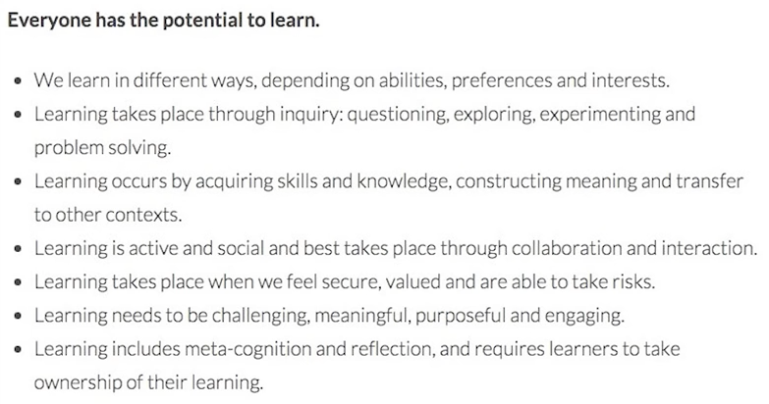

(Richardson, 2015)

Action Research is a method used for improving practice. It involves action, evaluation, and critical reflection and – based on measurable evidence gathered – changes in practice are then implemented once the driving question has been identified.

The ADDIE model is a popular instructional design model that has a step-by-step process that helps create effective instruction. Almost all instructional design models contain core elements of the ADDIE (Dempsey & Reiser, 2012). The ADDIE model has become a popular term used to describe a systematic approach to instructional design (Dempsey & Reiser, 2012) (Allen, 2013). The ADDIE model revolves around the following five components shown in the graphic organizer below:

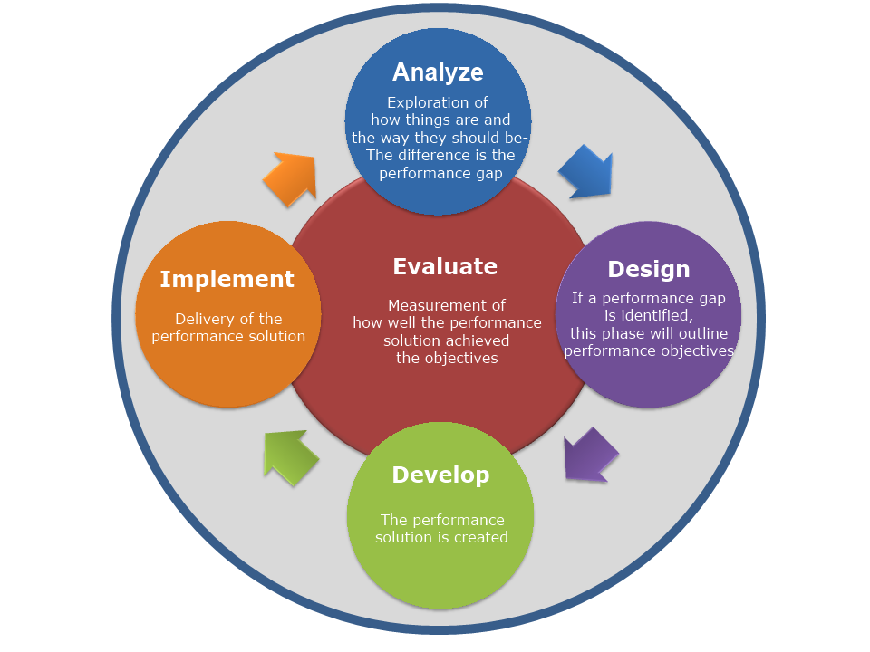

**A**nalyze **> D**esign **>** **D**evelop **> I**mplement **>** **E**valuate

Analysis of teaching methodologies and practices will reveal where possible changes in instructional design and leadership may be revised to promote diversity, inclusion, and equal access. Incremental checkpoints may be used as baseline assessments. Checkpoints are based on whether or not the students (these could be teachers, too) are meeting targeted goals. The model for learning must remain fluid and flexible to some degree at all times. That is vital to the success of any such collaborative effort. There’s no “perfect fit” to most things, especially things that are organic by design, which include multiple layers (e.g., programming, curriculum, implementation, individual teachers, Professional Learning Communities, the school site, the district, the state, etc.). Since teaching is an art it is important that as many components as possible remain fluid based on the overarching vision and how it supports the population that we serve.

Teachers actively educate themselves about the context that their students live in and dedicate themselves to lifelong learning to create inclusive learning communities. Some ways that support teachers to do their jobs better include smaller class sizes (20:1 maximum), heterogeneous student groupings, collaborative problem solving (by students and teachers), and specialized instructional support above and below the standardized levels to help to remove many potential learning barriers.

**Capacity Building**

Expectations, Ethics and Values – strategies for setting expectations of sharing personal and professional ethics and values of the school requires building alliances within every segment of the learning community– require including and activating all stakeholders including staff, students, parents, community members, school board members, and everyone connected in every capacity. Communication may be done in person, through email or standard mail, online through the school website, or via social media outlets (Facebook, Twitter, blogs, etc.) to put the message of the vision and practices in front of people to build their capacity to engage.

Networking plans and strategies for garnering support to network with community professionals to support me as a leader in the community and the school could include everything from fundraising in the community, to project-based learning that includes outreach efforts that integrate long lasting policies and choices, and everything else in between. Districts, schools, and educators need to reflect on what’s working – and what’s not – and be able to articulate change before the change can begin to take shape (Schwartz, 2016). In a continuous effort to increase communication with all stakeholders, the school website could have the option to translate content into multiple languages (e.g., Chinese, Korean, Spanish, German, French, etc.).

Common-sense cross-disciplines include building in and solidifying ties to unify the collective group of stakeholders. The “old school” model of the industrialized era doesn't fit the 21st Century Classroom model. The visionary principal knows that providing excellent public education is to empower all to achieve his or her fullest potential as productive global citizens. Teachers’ commitment to creating inclusive learning communities, in safe, supportive, and collaborative environments requires first addressing the needs of each student.

Current research on grouping and teaching students confirms that teaching to reach all learners needs to adapt in order to reach the needs of all learners. In addition to smaller class sizes and mixed ability grouping, research supports that teachers need to adapt the implementation and the intention of the development and delivery of content. According to Schwartz (2016), “Schools and districts need to be asking themselves difficult questions to propel change. The successful ones are letting the answer to the question, ‘How do kids learn best?’ drive everything they do in schools.” Pedagogical competency is determined by student data and student work– their work will confirm whether they’re “getting it” and if not, why not? (Russ Cornell, personal communication, July 16, 2016).

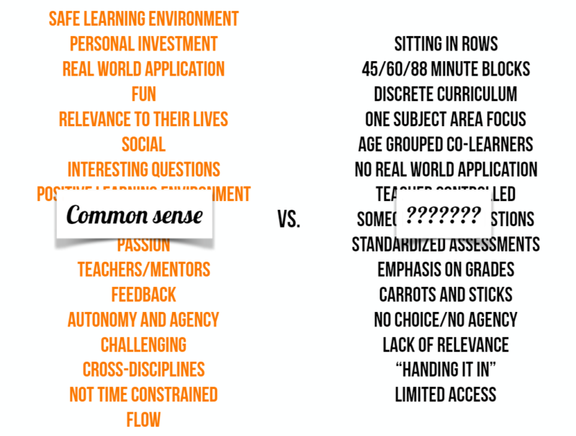

(Schwartz, 2016)

**Shared Governance, Professional Development, and Reflection**

Assessing a school’s readiness for change requires the principal to:

* participate as an equal;
* be enthusiastic;
* build trust and encourage a team spirit.

Above all, the successful principal must promote classroom instruction and provide opportunities for teachers to meet and reflect on teaching and learning, while supporting voluntary participative decision-making in the school and encourage a problem-solving approach. Finally, the principal must protect the integrity of decisions that are shared with teachers, surrender power, be flexible and dare to challenge the status quo (Blase & Blase, 2001).

Sustainable change takes time, commitment, and consistency. The vision is the driving force behind all actions, big or small. Substantive instructional improvement happens through dedicated and motivated staff members. Support and praise are two ways to build motivation including reimbursement for professional development, arranging for substitute teachers as requested, goal setting support, flexible time off in exchange for additional hours spent improving teaching practices, scheduled weekly meetings, and time to observe and work with colleagues to share best practices.

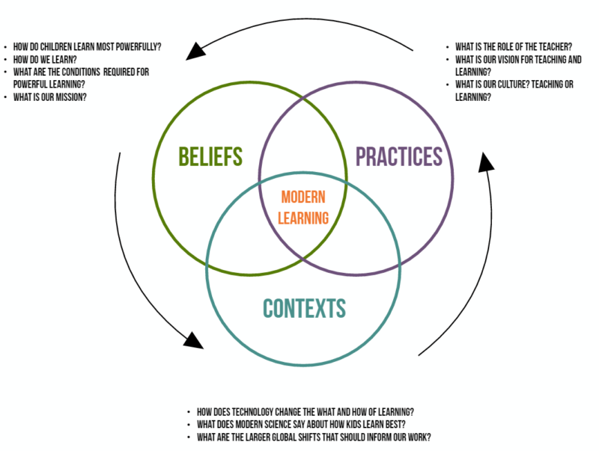

(Schwartz, 2016)

**Creating a Culture of Adults Learning**

“(A culture of adults learning includes) shared governance, professional development and reflection to establish collegial decision-making, structures and to promote teacher involvement in school-wide instructional and curricular decisions based for school improvement” (Glickman, 1984). The principal’s role in leading a school staff through an action planning process involves:

* Focus on instructional leadership and empowering students
* Student centered visionary approach with rich academic and enrichment programming
* Positive climate characterized by shared leadership, participative decision-making, collective interaction, and teacher autonomy grounded by respect and dignity
* Educators are involved in creative problem solving
* Educators support effective professional development for each other
* Parents and community are actively involved

(Blase & Blase, 2000)

**Creating Productive Professional Learning Communities**

A focus on continual professional development as it directly relates to staff and student learning requires intensive reflection upon instructional practices. Professional Learning Communities (PLC’s) enable teachers to continually learn from each other via shared vision and planning. This six-step process includes study, select, plan, implement, analyze, and adjust. Prior to beginning the process, teachers review student data to identify a specific standard or standards on which many students are not meeting a goal. This approach is a long-term plan and takes several years to develop fully.

* Teachers work in collaborative planning teams to examine critically and discuss standards-based learning expectations for students.
* These teams select evidence-based instructional strategies for meeting the standards.
* Teams develop a common lesson plan incorporating the selected strategies and identify the type of student work each teacher will use to demonstrate learning.
* Teachers implement the planned lesson, record successes and challenges, and gather evidence of student learning.
* Teams review student work and discuss student understanding of the standards.

Teams reflect on the implications of the analysis of student work and discuss potential modifications to instructional strategies. PLC’s work best when there is a culture of supportive collaboration, shared ability to look both closely and from a broad view without bias, and operate from a core set of shared beliefs and behaviors (Education World, 2012).

**Conclusion**

The principal’s primary responsibility is to improve teaching and learning at the school site. To do so requires a collaborative community that is committed to building a school culture where there are respect and cooperation among every student, adult, and family. Measurable growth is data based, as staff engages in critical examination and ongoing reflection with a strong commitment to lifelong learning. School policies, norms, and the teaching practices are directly linked to learning, therefore need the ongoing support of the internal processes required to achieve desired goals.

The vision is implemented through leading by example. Sharing the vision is all about making connections– connections to the content, to each other, to the community, and to the world. Learning through discovery and play creates a culture where both the students and the teachers are learners. When the vision embeds a set of core values about learning that is visible through shared behaviors learning process and results are clear to see. In these ways, students and staff are consistently united around the vision through shared leadership and equity for all learners. In summary, I will conclude with the words of Joe Blase (2001):

It is important to be a critical humanist; support the goals of democracy; demonstrate democratic principles to teachers, parents, and students; involve everyone in democratic decision-making. Going further, adopt an ethic of caring. Develop a nurturing community for children of all races, classes, and genders. Operate from your personal values. Lead with soul, with passion, with purpose. Provide moral leadership in your school.

Sharing best practices, bringing all stakeholders together, expectations for personal and professional ethics and values, and working together to build capacity to support the school vision are united by the leadership and vision of the principal, and shared through common core values and ethical practices of the entire staff and community.

**References**

Allen, M. (2013). *ADDIE Overview*. Retrieved from http://edtc6321t2.pbworks.com/w/page/58812937/ADDIE%20Overview

Blase, J., & Blase, J. (2001). *Empowering Teachers: What Successful Principals Do* (2nd ed.). Thousand Oaks, CA: Corwin Press.

Provini, C. (2012). Best Practices for Professional Learning Communities. Education World. Retrieved from http://www.educationworld.com/a_admin/best-practices-for-professional-learning-communities.shtml

Richardson, W. (2015, November 21). The Surprising Truth About Learning in Schools [Video file]. Retrieved from You Tube website: https://www.youtube.com/watch?v=sxyKNMrhEvY

Schwartz, K. (2016). *How Can Schools Prioritize For The Best Ways Kids Learn?*Retrieved from http://ww2.kqed.org/mindshift/2016/07/18/how-can-schools-prioritize-for-the-best-ways-kids-learn/

The Classical Academy. (2014). Retrieved from http://www.classicalacademy.com/career/

Ubben, G. C., Hughes, L. W., & Norris, C. J. (2016). *The Principal: Creative Leadership for Excellence in Schools.* Boston: Pearson.

University of Phoenix. (2016). *Educational Impact: Community Support Comes from More than Just Parents.* Simmons, Warren. Retrieved from University of Phoenix, EDL/510 website.